**附件3：滇池国家旅游度假区消防救援大队体能考核标准**

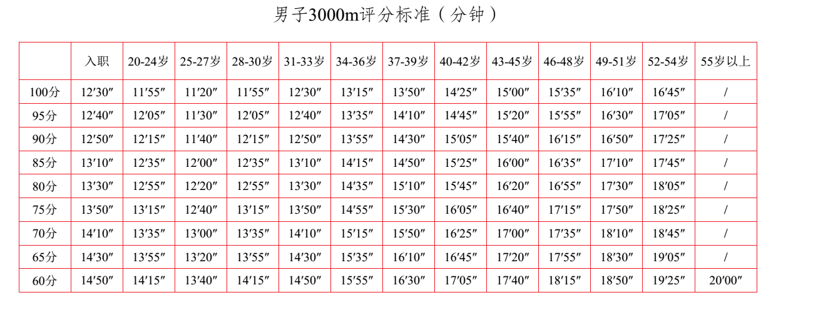

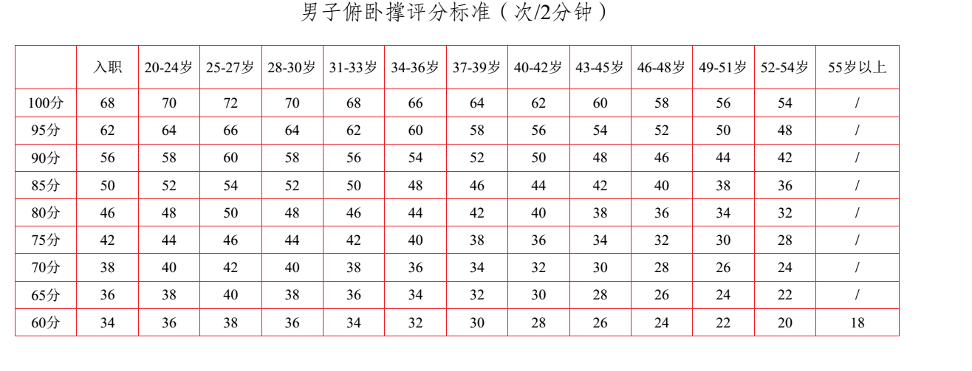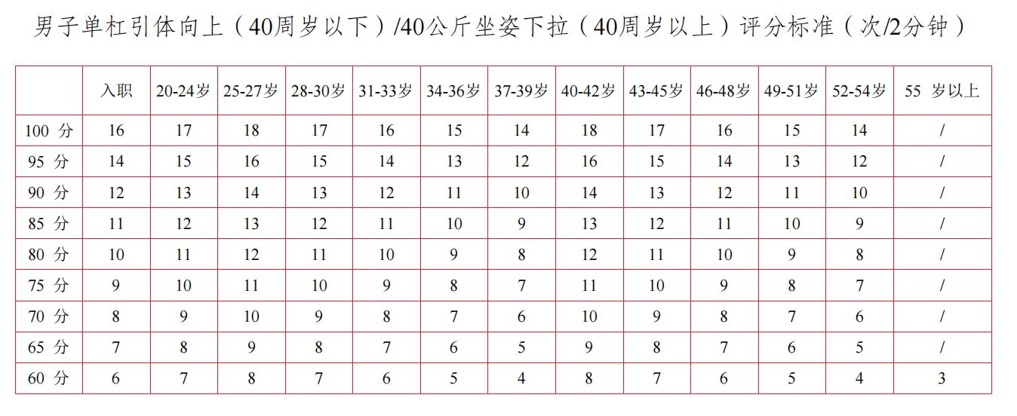

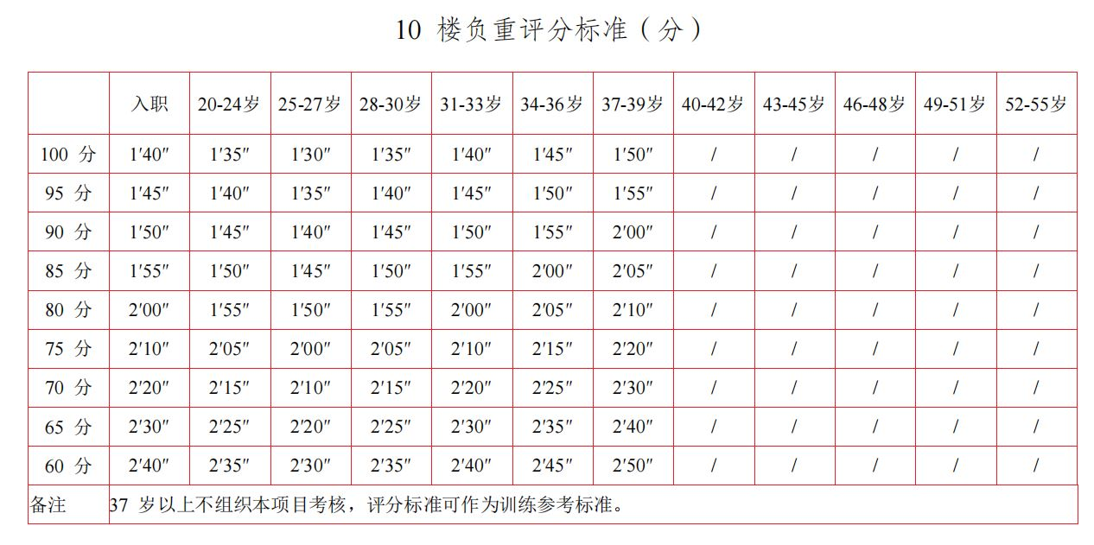

|  |  |  |  |  |  |  |  |  |  |
| --- | --- | --- | --- | --- | --- | --- | --- | --- | --- |
| 100米评分标准 | | | | | | | | | |
| 成绩 | 13″70 | 14″00 | 14″30 | 14″60 | 14″90 | 15″20 | 15″50 | 15″80 | 16″00 |
| 得分 | 100 | 95 | 90 | 85 | 80 | 75 | 70 | 65 | 60 |